**Big Query Tables**

**Tables naming:**

* Table names are case-sensitive by default. mytable and MyTable can coexist in the same dataset, unless they are part of a dataset with case-sensitivity turned off.
* Some table names and table name prefixes are reserved. If you receive an error saying that your table name or prefix is reserved, then select a different name and try again.
* If you include multiple dot operators (.) in a sequence, the duplicate operators are implicitly stripped.For example, this: project_name....dataset_name..table_name, Becomes this: project_name.dataset_name.table_name  
  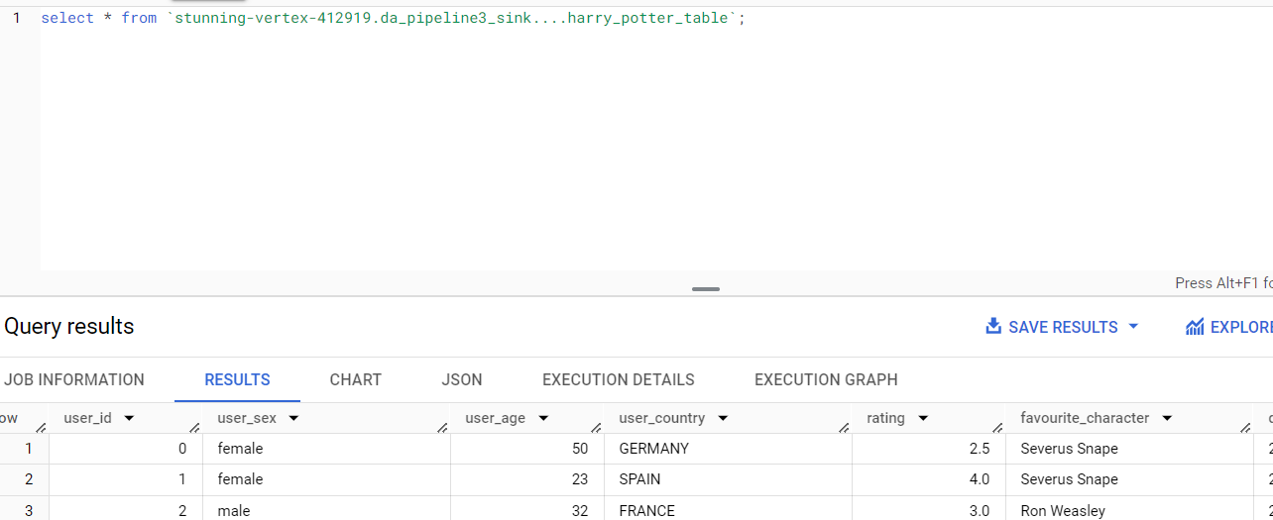
* The following are all examples of valid table names: table 01, ग्राहक, 00_お客様, étudiant-01.

**Table Creation:**

We can create Big Query tables either form UI, bq commands and by running SQL queries.

**External Tables:**

An external data source is a data source that you can query directly from BigQuery, even though the data is not stored in BigQuery storage. For example, you might have data in a different Google Cloud database, in files in Cloud Storage, or in a different cloud product altogether that you would like to analyze in BigQuery, but that you aren't prepared to migrate.

Use cases for external data sources include the following:

* For extract-load-transform (ELT) workloads, loading and cleaning your data in one pass and writing the cleaned result into BigQuery storage, by using a CREATE TABLE ... AS SELECT query.
* Joining BigQuery tables with frequently changing data from an external data source. By querying the external data source directly, you don't need to reload the data into BigQuery storage every time it changes.

**Access Control:**

To provide access to any person or group or a service account to a particular table. We need to click on the table-> share and then mention the principal name to whom we want to give the access to. Then we can specify any roles or IAM conditions.

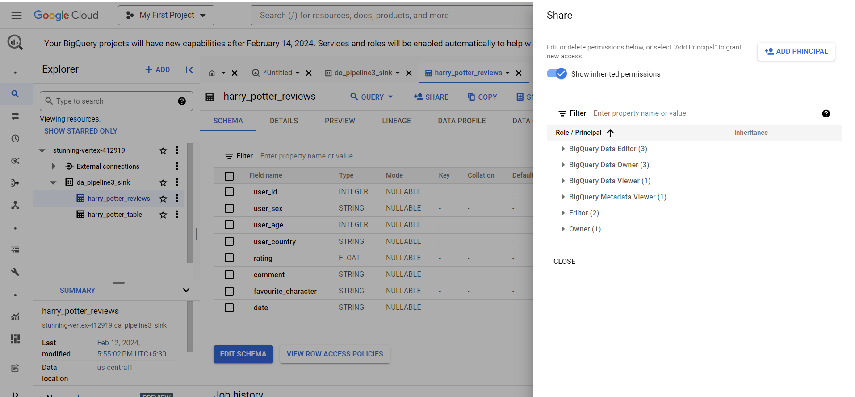  
  
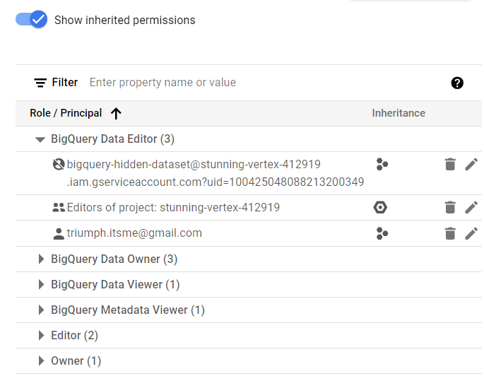

WE can see the inherited permission also as seen in above screenshot.

**Security:**

**Column level access control:**

**Row level access control:**

**Data Masking:**